**TO THE CMO**

On investigating the [overall marketing performance for Q2](https://drive.google.com/file/d/1mJXymFEia5rG9fv1uNKMiugOSCNuo5tH/view), the design and size preference trends of our product x is consistent throughout the quarter.

* Purchase tendency of customers throughout this quarter has been specific to particular design and color.
* Odd number sizes (1,3,5) have relatively lower purchase rate.

**RECOMMENDATION:**

* Instrumenting customer surveys to targeted new and returning customers will help us better understand their purchase behavior and design selection tendency. This data can be used in three ways:

1. Scope of add-on option in checkout page
2. Scope for any deals or promotions (e.g.: combo deals)
3. Eliminating designs that are under-performing/ less favorable by the customer.

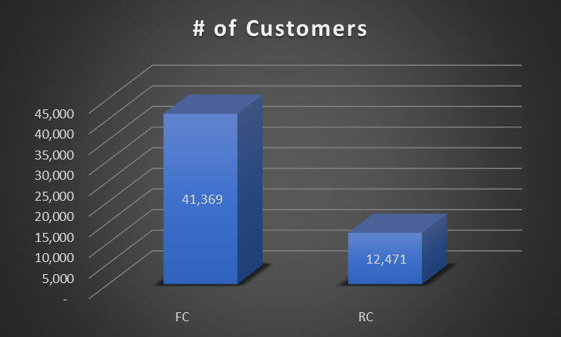**TO THE DIRECTOR OF RETENTION:**

From the Q2 marketing spend & sale data, there were some observations, that I wish to bring to your attention:

* Returning customer percentage averaged around 23% for Q2.
* The LTV of Returning customer is thrice that of first-time customers.
* *\*\*All assumptions are highlighted in yellow, Customer lifetime is referenced from the following website:* [*https://www.shopify.com/blog/customer-lifetime-value*](https://www.shopify.com/blog/customer-lifetime-value)

|  |  |  |  |
| --- | --- | --- | --- |
| **FC** |  | **RC** |  |
| Average purchase value | $ 13,739 | Average purchase value | $ 13,739 |
| Average purchase frequency (per year) | 1 | Average purchase frequency (per year) | 3 |
| Customer value | $ 13,739 | Customer value | $ 41,217 |
| Customer lifetime (years) | 3 | Customer lifetime (years) | 3 |
| **LTV** | **$ 41,217** | **LTV** | **$ 123,651** |

**RECOMMENDATION:**

* Introduce programs like loyalty benefits, newsletter (about product x care, product x cleaning etc.,- keeping the blog tab on the home page of the website helps too), gift-card option to increase customer retention, as we see above, the returning customers bring about thrice the revenue.

**ASSUMPTIONS:**

1. The values in the raw data are assumed to be true
2. These values are assumed to be true for the rest of the year and LTV is calculated on the assumption for the given data only.